Name: Harshavarthini Annamalai Roll No: 240701181

EXPERIMENT 5

Users, Roles and Permissions in Zoho Creator

Aim

To study the process of managing users, defining roles, and configuring permissions in the Zoho Creator platform, and to understand how access control is implemented for different users within an application.

Introduction
Zoho Creator provides a comprehensive user management system that allows administrators to control who can access an application and what actions they can perform. The platform uses a combination of Users, Roles, and Permissions to implement role-based access control (RBAC). Users are individuals who are granted access to the application. Roles define the hierarchy and responsibilities of users within the application. Permissions determine the specific actions a user or role can perform on different modules and records. This structured approach ensures data security and proper access management in multi-user applications.

Objectives of the Study
- To understand the concept of users, roles, and permissions in Zoho Creator.
- To learn how to add users to an application and assign roles.
- To understand the role hierarchy and how it affects data visibility.
- To learn how to create and manage custom permissions.
- To explore data sharing settings between peers and subordinates.
- To develop a complete access control system for a business application.

Procedure
- Log in to the Zoho Creator platform.
- Open the required application or create a new application.
- Navigate to the Settings section and select User Permissions.
- Add users to the application by providing their email address and name.
- Assign appropriate roles to the users from the available roles list.
- Create new roles based on the organizational hierarchy using the Roles tab.
- Configure role details such as Role Name, Reports To (parent role), Share Data with Peers, and Description.
- Create custom permissions using the Permissions tab.
- Configure module-level permissions for each permission profile (Access, View, Edit, Delete).
- Set API and Security Permission settings as required.
- Assign permissions to roles and users.
- Configure Data Sharing settings to define record visibility.
- Save and verify the configuration by testing with different user accounts.
- Publish the application after completing the user and permission setup.

Illustrative Example
Consider a Food Delivery System in which different users such as CEO, Admin, Staff, and Customer interact with the application. Each user requires different levels of access to the application's data and functionality.

Implementation using Zoho Creator

Create a Food Delivery System application and configure users, roles, and permissions as follows:

Roles Hierarchy:

CEO (top-level role)

Admin (reports to CEO)

Staff (reports to Admin)

Customer (reports to Staff)

Permissions Profiles:

Admin permissions – Admin permissions Profile

Read – Read permission for all components

Staff Permissions – Staff Permissions Profile

Write – Write permission for all components

User Assignment:

User: harshavarthiniannamalai.2024.cse@rajalakshmi.edu.in

Name: HARSHAVARTHINIANNAMALAI 240701181

Role: Staff

Permission: Staff Permissions

Module Permissions for Staff Permissions Profile:

Customer Profile: Access ✓, View (2 Reports), Edit (2 Reports)

Menu Item: Access ✓, View (2 Reports), Edit (2 Reports)

Order Line Item: Access ✓, View (All Order Line Items), Edit (All Order Line Items)

5.2 Illustrative Design

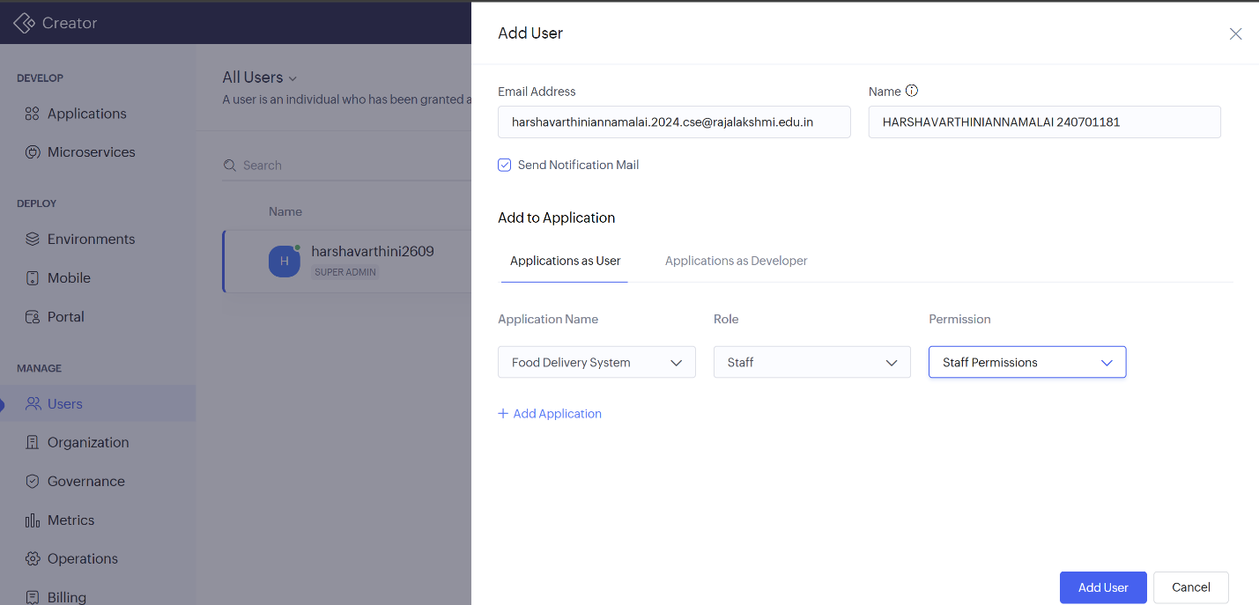

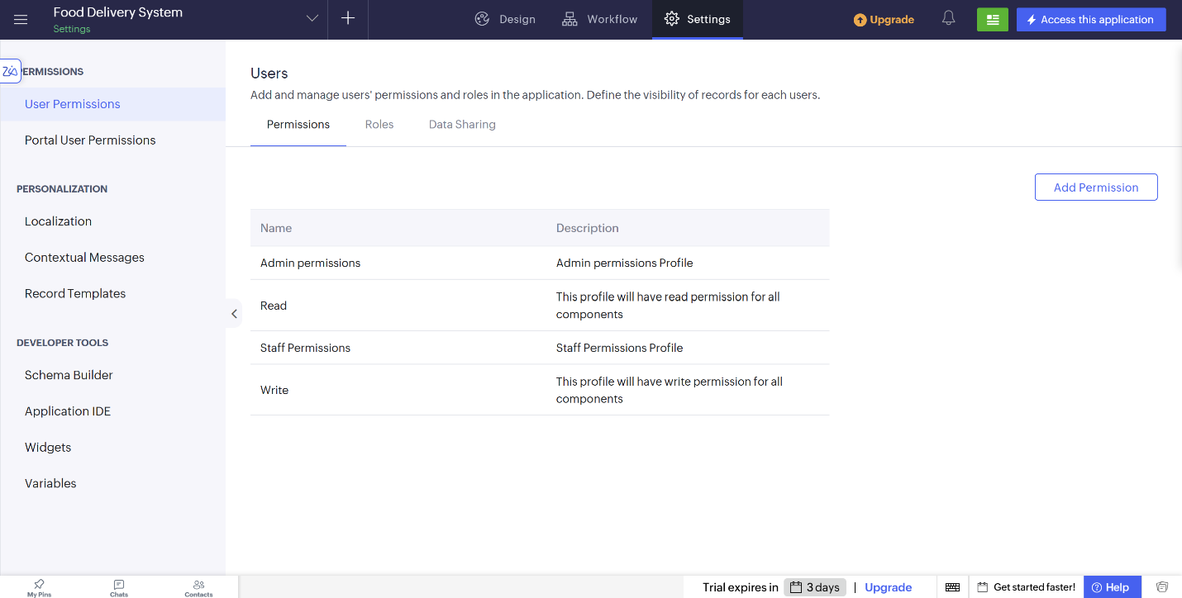

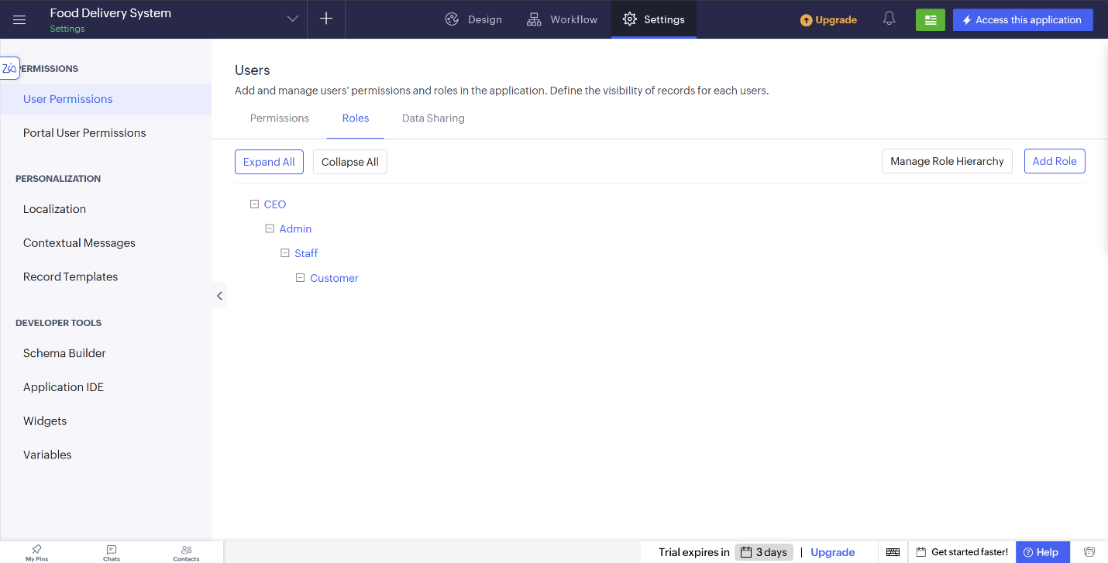

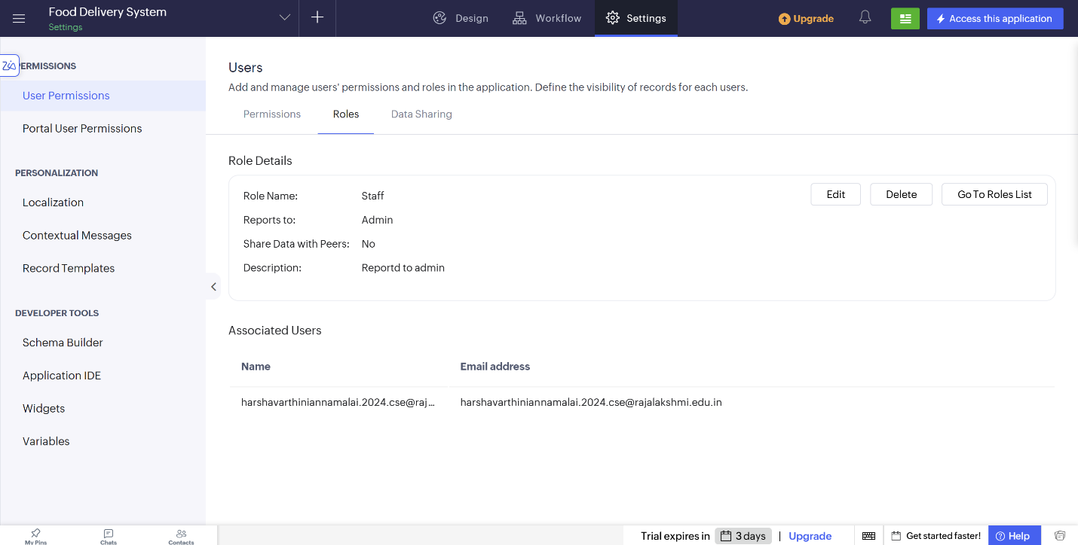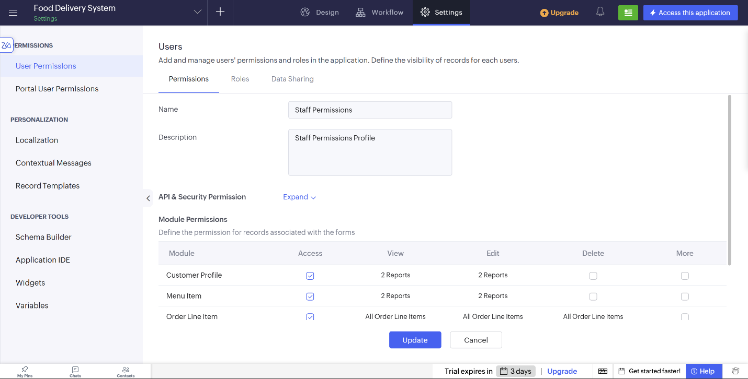

6. Advantages and Limitations
6.1 Advantages
    - Provides structured role-based access control for applications.
    - Ensures data security by restricting unauthorized access.
    - Role hierarchy simplifies the management of user responsibilities.
    - Permissions can be configured at both user and role levels.
    - Data sharing settings allow controlled collaboration between peers.
    - Reduces administrative overhead by grouping users under roles.

6.2 Limitations
    - Complex permission structures may require careful planning.
    - Misconfigured permissions can lead to data exposure or access issues.
    - Large organizations may need additional customization.
    - Role hierarchy changes may require reassignment of users.
    - Advanced permission logic may require Deluge scripting.

7.Result
The experiment was completed successfully by studying user management, role definition, and permission configuration in Zoho Creator. The exercise demonstrated how users, roles, and permissions can be combined to implement a secure and structured access control system for a business application with reduced manual effort.

